42.19: a) To be detected the photon must have enough energy to bridge the gap width 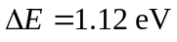
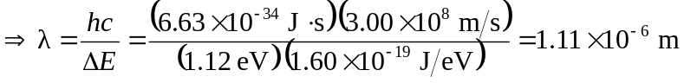, in the infrared.
b) Visible photons have more than enough energy to excite electrons from the valence to conduction band. Thus visible light is absorbed, making silicon opaque.

